Let’s celebrate all the fun reading brings to our lives!

WHEN: February 25-March 1
WHERE: JHIS
WHY: Reading is the key to
success!
HOW: Follow the list below!

1. Participate in “OH, THE PLACES YOU’LL GO” theme days, and your homeroom may win a prize from the PTA!

2. Participate in the BOOK SWAP and/or the BOOK DRIVE.

3. Enjoy surprise guests on morning announcements and mystery readers during your library class.
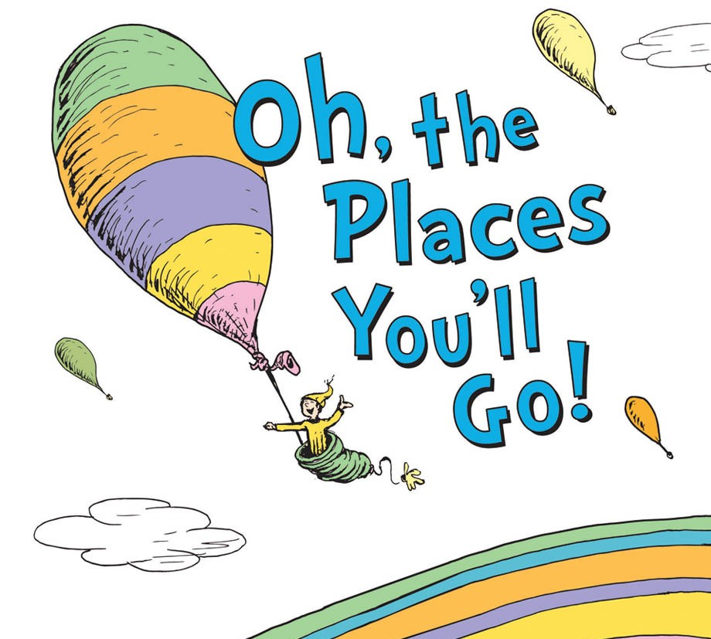

Mon., Feb. 25- Visit the Southern Hemisphere Wear black and white to dress like a penguin and be ready for the Aviary Assembly.

Tues., Feb. 26- Imagination Day
Wear something that uses your imagination like Harry Potter, Disney, Super Heroes, animals in stories, etc.

Wed., Feb. 27- Day in the U.S.
Wear something from a team, college, city, or state in the United States. It can even be a symbol that represents a state.

Thurs., Feb. 28- Island Day
Wear your favorite beach or summer clothes and shoes!

Fri., March 1- Pajama Day
You can always cozy up and read all the places you go!
A flyer already came home with all the details. Students can bring up to three “gently used” books to swap for others. Students must bring the books along with the signed slip from a parent to participate.

Feb. 18-22- Books are brought to the Media Cafe during library class.

Feb. 25-March 1- Students select their new books during Read Across America Week.
Students can donate extra “gently used” books to the book drive. These books will be given to a local place in need of children’s books.

