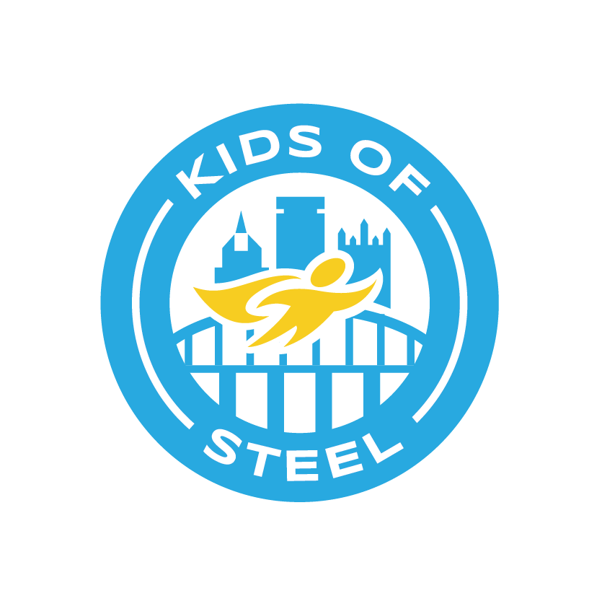
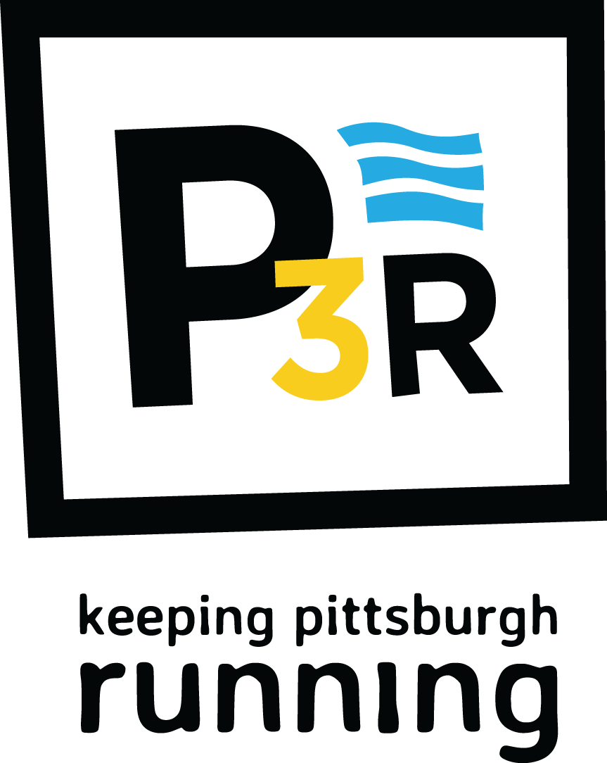
Dear Parent/Guardian,
We are excited to share that Jefferson Elementary is participating in the Kids of STEEL program from P3R, a nonprofit organization that is passionate about promoting the love of running and enhancing community access to health & fitness education and activities.

Kids of STEEL (KOS) is an award-winning, free youth physical activity and nutrition program designed to
instill lifelong, healthy habits in children. Each training plan is geared towards age-appropriate exercise and healthy eating habits. See the back of this letter for information on the different training plans.

During the training period, children will:
● Complete physical activity and nutrition goals based on their chosen training plan.
● Learn the benefits of setting a goal, training for the goal and achieving that goal.
● Track activity and nutrition goals on a training log and turn it in for a finisher prize.
● Have the option to complete the program at one of three event on Saturday, May 5, 2018 during the DICK’S Sporting Goods Pittsburgh Marathon weekend of events.

Children can participate in the free Kids of STEEL training plan and not register for a race. ALL
PARTICIPANTS MUST REGISTER FOR THE KIDS OF STEEL PROGRAM AND COMPLETE A
LIABILITY WAIVER, EVEN IF THEY WILL NOT ATTEND A RACE.

Registration information is listed on the back of this letter. The Toyota Pittsburgh Kids Marathon and Pittsburgh Toddler Trot have sold out in previous years, so please register early. Once you register online through RunSignUp, you will receive a confirmation email from P3R with a program guide that includes training plans and training logs.
Where to Train?
At School: Look for I Ran a ½ Mile Today coupon in your child’s backpack & log the mileage onto their
training log. Students will have the opportunity to run during their lunch recess on B and D days.
At Home: For every 20 minutes of physical activity, children earn 1 mile. Log the activity onto their
training log.

Please feel free to contact Mrs. Conboy (lconboy@wjhsd.net) or Mr. Guidash (dguidash@wjhsd.net)

Sincerely,
Mrs. Conboy
Mr. Guidash
PE Department
Jefferson Elementary School

KIDS OF STEEL TRAINING PLANS
1. When you register, please make sure you choose Jefferson Elementary School to be included on our team. If we pick up Kids Marathon race items prior to race day and your child isn’t listed with our school, his/her items will not be boxed up. This includes siblings…if they aren’t listed with our school, we will not receive their items. Please choose our school when registering siblings.

2. If you are registering for the 5K, please choose our site name for child AND any adults running with the child. If we are able to pick up race items prior to race day, we will get the adult’s items as well.

3. During registration, you will be asked “Is your child participating in Kids of STEEL?” Please choose YES.

4. If you are unable to register online, please contact your site coordinator for a paper registration.

5. If your child would like to register for a race but you need financial support, please contact your site coordinator.

Program Choice | Cost | Benefits | Online Registration Info
Kids of STEEL ONLY  No Race – all 26 miles are done at school | FREE | - Training log  - KOS finisher prize | Deadline: March 1, 2018.  Kids of STEEL only (no race) https://runsignup.com/Race/PA/Pittsburgh/KidsofSTEEL
Kids of STEEL and Pittsburgh Toddler Trot | $10 per child  Adult is free | - Training log  - KOS finisher prize  - Toddler Trot race number, shirt and finisher medal | Deadline: March 31, 2018 or until race sells out  https://runsignup.com/Race/PA/Pittsburgh/DICKSSportingGoodsPittsburghMarathon  Click the ‘Register Now’ button and choose Pittsburgh Toddler Trot
Kids of STEEL & Toyota Pittsburgh Kids Marathon  (1mile)  25 miles done at home or school & last mile done in Pittsburgh | $20 per child  One adult runs free; additional adults $10 each | - Training log  - KOS finisher prize  - Kids Marathon race number, shirt, goody bag and finisher medal | Deadline: March 31, 2018 or until race sells out  https://runsignup.com/Race/PA/Pittsburgh/DICKSSportingGoodsPittsburghMarathon  Click the ‘Register Now’ button and choose Toyota Pittsburgh Kids Marathon & Kids of STEEL
Kids of STEEL and  UPMC Health  Plan/UPMC Sports  Medicine Pittsburgh 5K Run  (3.1 miles) | $30 per person until March 31, 2018; $50 per person after that date. Must use a coupon code to receive discounted rate. | - Training log  - KOS finisher prize  - 5K race number, shirt, goody bag and finisher medal | Deadline: March 31, 2018 or until race sells out  https://runsignup.com/Race/PA/Pittsburgh/DICKSSportingGoodsPittsburghMarathon  pittsburghmarathon.com. Click the ‘Register Now’ button and choose UPMC Health Plan/UPMC Sports Medicine Pittsburgh 5K Run & Kids of STEEL  Contact site coordinator for discount coupon code.

